# **Axe DevTools Test Results**

*02/01/2024*

**Page: GI Bill Comparison Tool: comparison page**

Note: “Total Issues” comprises the total count of accessibility violations found at the currently selected hierarchy level. Issue count on the right side of the Overview tab (e.g., “15 issues”) represents the total number of accessibility tag violations.

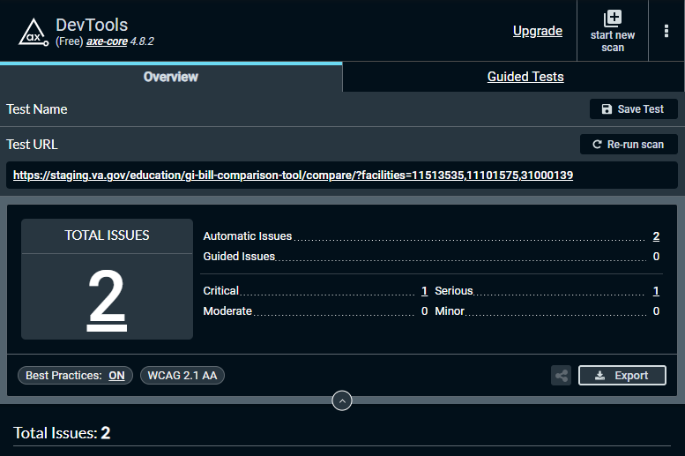

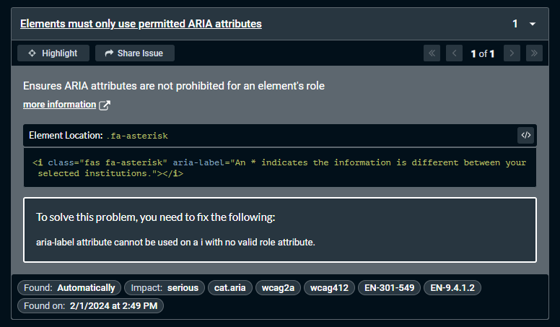

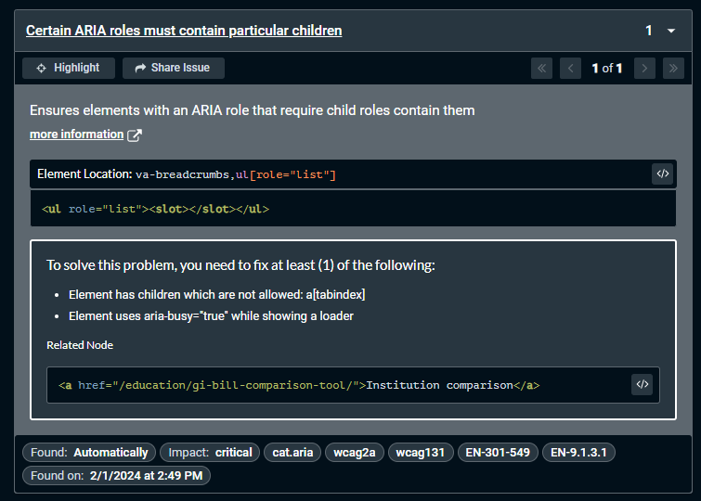

# **Axe DevTools Test Results**

*02/01/2024*

**Page: GI Bill Comparison Tool: school details page**

Note: “Total Issues” comprises the total count of accessibility violations found at the currently selected hierarchy level. Issue count on the right side of the Overview tab (e.g., “15 issues”) represents the total number of accessibility tag violations.

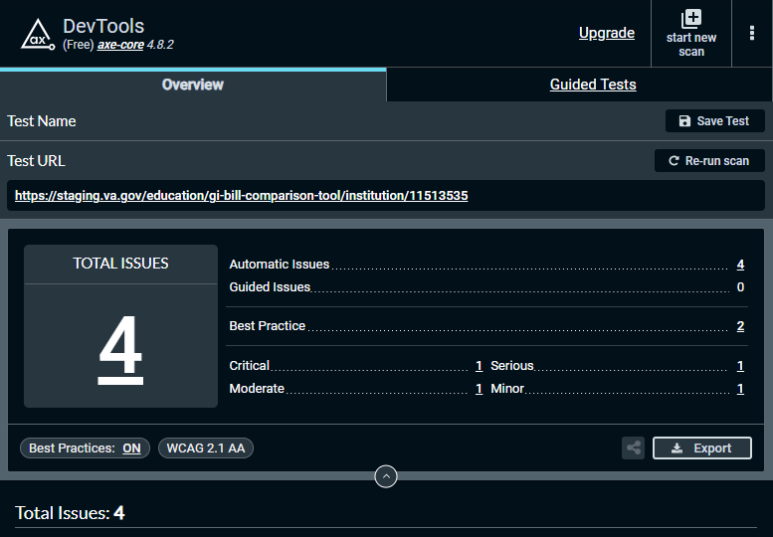

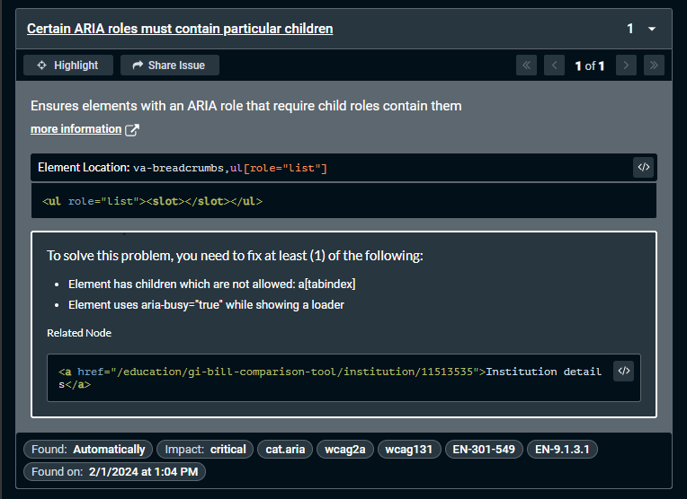

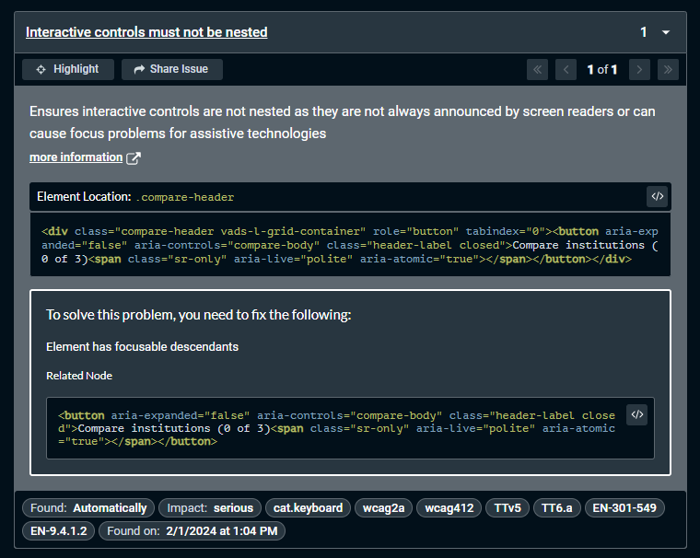

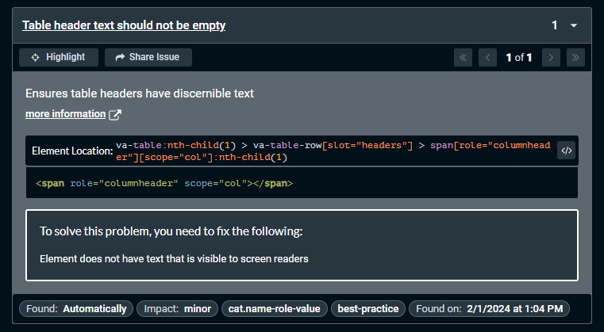

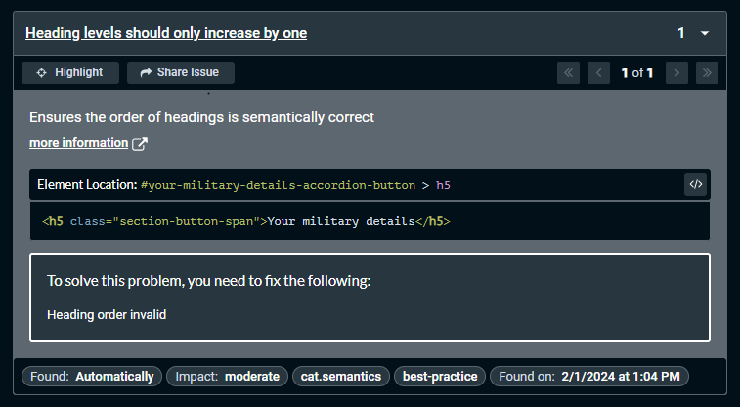

# **Axe DevTools Test Results**

*02/01/2024*

**Page: GI Bill Comparison Tool: school details page**

Note: “Total Issues” comprises the total count of accessibility violations found at the currently selected hierarchy level. Issue count on the right side of the Overview tab (e.g., “15 issues”) represents the total number of accessibility tag violations.











# **Axe DevTools Test Results**

*01/31/2024*

**Page: GI Bill Comparison Tool home page: Search by location, with results**

Note: “Total Issues” comprises the total count of accessibility violations found at the currently selected hierarchy level. Issue count on the right side of the Overview tab (e.g., “15 issues”) represents the total number of accessibility tag violations.

